## **1. Introduction:**

This document outlines the system architecture for the post-knee replacement gait analysis project using video-based input. The system leverages deep learning approach to LSTM to analyze gait parameters from MOV file-based input. The architecture and data flow diagrams illustrate the key components and processing pipelines.

## **2. System Architecture:**

Fig 1 - Architecture diagram

**Components of Architecture**

1. **Data Collection**:
   * MOV files recorded under controlled conditions
   * Standardized camera setups for capturing patient gait
2. **Data Ingestion & Preprocessing**:
   * Frame extraction from MOV files
   * Noise reduction and image enhancement
   * Skeleton detection using MediaPipe
3. **Feature Extraction & Model Processing**:
   * Spatial feature extraction using HSV color segmentation
   * Temporal pattern analysis using LSTM
   * Key gait parameter computation (e.g., stride length, cadence)
4. **Post-Processing & Evaluation**:
   * Smoothing of extracted gait features
   * Comparison with clinical gait benchmarks
   * Identification of gait abnormalities
5. **Visualization & Reporting**:
   * Dashboard for displaying gait metrics
   * Progress tracking for post-surgery rehabilitation

## **3. Data Flow Diagram:**

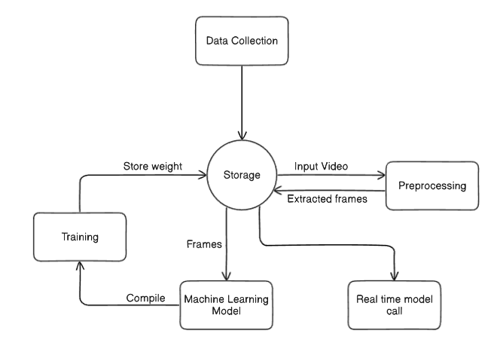

Fig 2 - Data Flow diagram

1. **Raw Video Input (MOV files)** → Frame Extraction
2. **Preprocessing (Noise Reduction, Normalization, Augmentation)**
3. **Pose Estimation (MediaPipe)** → Key Points Extraction
4. **Feature Extraction (HSV color segmentation)** → Spatial Feature Representation
5. **Temporal Analysis (LSTM)** → Motion Sequence Processing
6. **Gait Parameter Calculation** → Stride Length, Joint Angles, Cadence
7. **Evaluation & Comparison** → Clinical Benchmarking
8. **Visualization & Reporting** → Gait Recovery Insights

## **4. Conclusion:**

The architecture integrates **deep learning techniques** for video-based gait analysis, providing a **non-invasive, accurate, and efficient** way to assess post-knee replacement recovery. Future improvements include **real-time analysis**, **higher-resolution tracking**, and **expanded datasets** for increased accuracy.